**Data Communication & Networking**

CEN 222



**Group Members:**

Muhammad

Abdullah (049)

Saad Ahmed (077)

CS-4B

**Project**

**Wi-Fi Repeater**



Table of Contents

*Abstract……………………………………………………………………………………………………………. 3*

*Introduction……………………………………………………………………………………………………. 3*

*Problem Statement…………………………………………………………………………………………………………………… 3*

*Objectives………………………………………………………………………………………………………. 3*

*Purpose…………………………………………………………………………………………………………... 3*

* *System scope………………………………………………………………………………………… 4*
* *User Scope…………………………………………………………………………………………… 4*

*Software tools Used………………………………………………………………………………………. 4*

*GitHub Link……………………………………………………………………………………………………… 4*

*Up roach…………………………………………………………………………………………………………. 4*

*Components Used…………………………………………………………………………………………. 4*

*Working…………………………………………………………………………………………………………. 4*

*Explanation…………………………………………………………………………………………………… 5*

* *Configuring…………………………………………………………………………………………... 6*

*Circuit Diagram………………………………………………………………………………………………… 6*

*Advantages of ESP8266 repeater……………………………………………………………………. 7*

*Limitations………………………………………………………………………………………………………. 7*

*Conclusion………………………………………………………………………………………………………. 8*

***Abstract***

We are from the Internet of Things (IoT) Generations. These days, we control our home appliances like air-conditioners, room heaters, water heaters, etc. remotely from anywhere. But for every Wi-Fi-based IoT-enabled device, we require uninterrupted Internet/Wi-Fi connectivity. The problem of Low Wi-Fi signal is very common due to interference from room to room or floor to floor. Many people face this problem in their daily lives. Everything needs the internet. Smart TV, smartphone, laptop, desktop computer, but you just have one router to provide a wireless connection on a house. Don’t worry we will build the cheapest and Portable Wi-Fi Repeater using ESP8266 NodeMCU.

***Introduction***

A Wi-Fi repeater is used to expand the coverage area of ​​your Wi-Fi network. It works by receiving your existing Wi-Fi signal, amplifying it and then transmitting the enhanced signal. With a Wi-Fi repeater you can effectively double the coverage area of ​​your Wi-Fi network – to reach the far corners of your home or office, on different floors, or to expand coverage in your yard and much more.

***Problem Statement***

So, the question is How can we access the internet in every corner of the house? If you have a big house single router is not enough to cover this range! Each footstep lowers the Wi-Fi signal. And it’s not good for a multi-story building So what solves this problem?

***Objectives***

* To create a hardware-based Wi-Fi Repeater using ESP8266.
* Should be able to configure through gateway.
* Test the repeater and show the working.

***Purpose***

The purpose of this research is to build a hybrid wireless range extender (HWRE) using ESP8266 that can help to increase the wireless signal strength that broadcasts from networks.

**System Scope:**

1. Enhance the range of the Wi-Fi.

**User Scope:**

1. User can experience more network coverage.

2. User can get better pace of performance in the internet while browsing.

***Software Tools Used***

* Flash Download tool
* GitHub (Esp_Wifi_Repeater_Master)
* NodeMCU Drivers

***GitHub Link***

*“*[*https://github.com/martin-ger/esp_wifi_repeater*](https://github.com/martin-ger/esp_wifi_repeater)*”*

***Approach***

There are no multiple ways to perform this task. Only NodeMCU is used to build any kind of Wi-Fi Repeater. That is why there was no other option to go with.

***Components Used***

|  |  |
| --- | --- |
| ***Components Name*** | ***Description*** |
| NodeMCU | ESP8266 12E Board |
| 18650 Battery | Rechargeable 3000mah battery |
| Jumper Cables | Male to male & Male to Female Jumpers |
| SPST Switch | On/Off Switch |

***Working***

By default, ESP acts as STA and forwards any IP traffic through it as a soft-AP and transparently. It does not require any routing entries as it uses NAT, either on the network side or on connected stations. The stations are configured via DHCP the 192.168.4.0/24 net and receive their DNS responding address from the existing Wi-Fi network.

***Explanation***

1. First, we had to install the required drivers to run the flash download tool.

2. Secondly, we have to plug the ESP8266 NodeMCU into the USB adapter, into the computer. After this step, we have to Flash the Repeater Firmware onto the ESP8266.

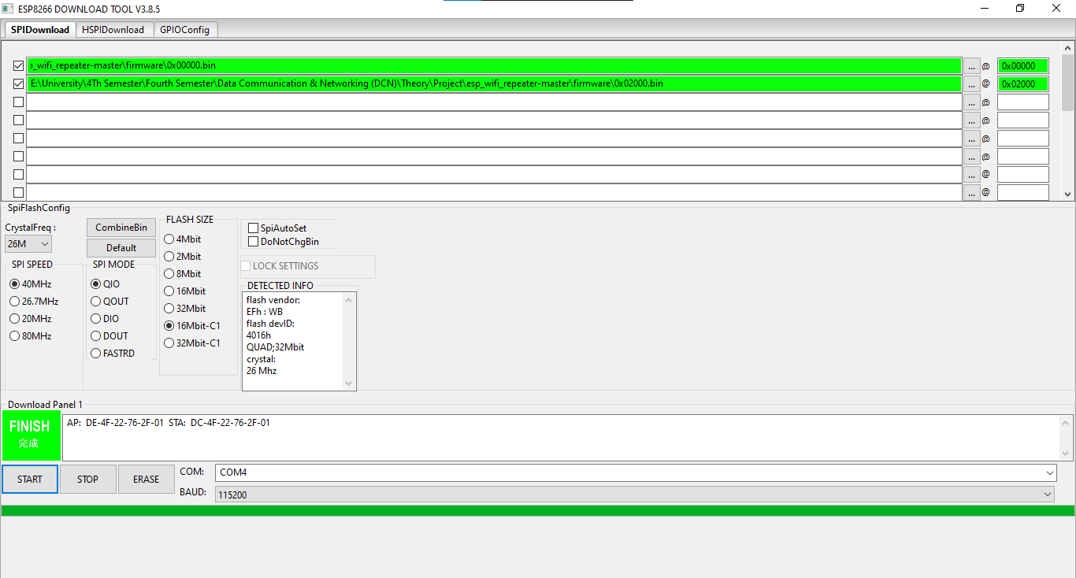

3. After finishing, we have to unplug the adapter and ESP8266 module from the computer.

4. Now, A Wi-Fi named as ‘MyAp’ would be available after the ESP8266 is given power supply.

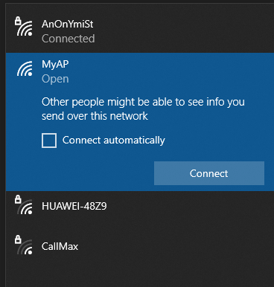

**Configuring Portable Wi-Fi Repeater using ESP8266**

5. Connect to this Wi-Fi network and perform basic configuration via a simple web interface.

The web interface allows for the configuration of all the parameters required for basic forwarding functionality. The following address allows us to configure the settings: <http://192.168.4.1>.

Here, we can change the AP settings according to our need and provide the STA Settings for the Wi-Fi we want to repeat and your Wi-Fi repeater is ready!

***Circuit Diagram***

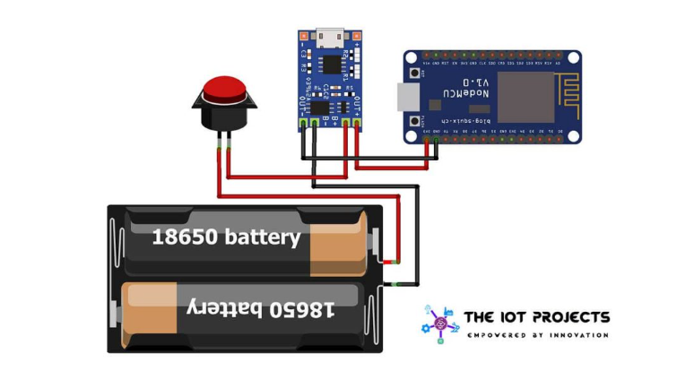

***Advantages of ESP8266 Repeater***

* Simple range expander for existing Wi-Fi networks
* Battery-powered (can be used while charging)
* Setting up an additional Wi-Fi network with different SSIDs / passwords for guests
* Establishing a secure and restricted network for IoT devices
* Translating WPA2 PSK to WPA2 Enterprise Network
* Monitor for Wi-Fi traffic analysis
* Simple design and low cost

***Limitations***

* Due to the limitations of ESP’s SoftAP implementation, only 8 stations can be connected simultaneously.
* The ESP8266 needs a good power supply as it produces a current spike of up to 1mA during transmission (normal average consumption is around 700 mA when Wi-Fi is turned on).
* Check the power supply first, if your ESP is unstable and reboots periodically. A large capacitor between VDD and GND can help if you experience problems here.
* The minimum input voltage is only 3.3V & the maximum input voltage is 8V.
* The maximum charging current is only 1A.
* Output charging voltage fixed at 4.2V (no alternative for different types of batteries – Life etc.)

***Conclusion***

Overall, in a nutshell, this project (Wi-Fi Repeater), can make such a big change for students and other users in the campus to access the internet for their use. The use of a wireless connector has several advantages which can make a process even more effective. It does, however, pose questions, as does all emerging innovation. Issues with protection and connections to a Wi-Fi connector, as well as the effect that it can seem to have limited users, are a few factors that are limiting wireless technology for developing. The issues associated with wireless connectivity can be minimized and it can become a more significant part of the user as more development and experimental studies are implemented.

**-- END --**